Step-by-Step Instructions to obtaining your departments reports from previous years.

- Click on this link https://www.usfa.fema.gov/nfirs/ and locate the Login or register option in the lower right-hand side of the screen as you see below. Once there, go ahead and register.
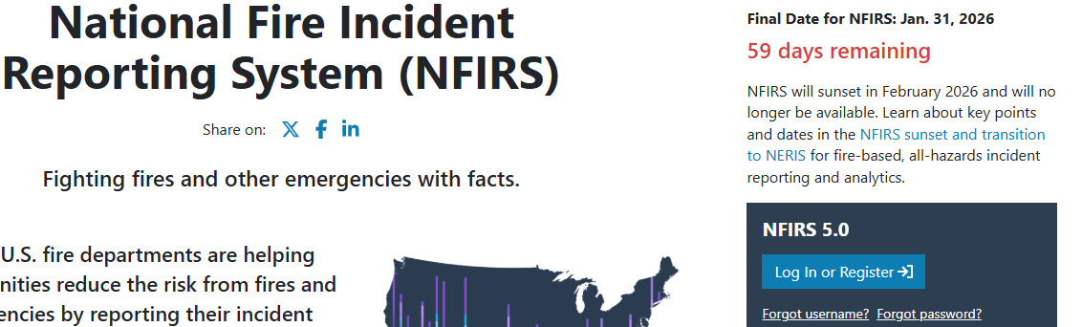

- Once you have registered, e-mail Richard Taylor at richard.e.taylor@maine.gov and let him know you’re register so that he can allow you into the system.
- Now go back to https://www.usfa.fema.gov/nfirs/ and go back to where you registered and click login.
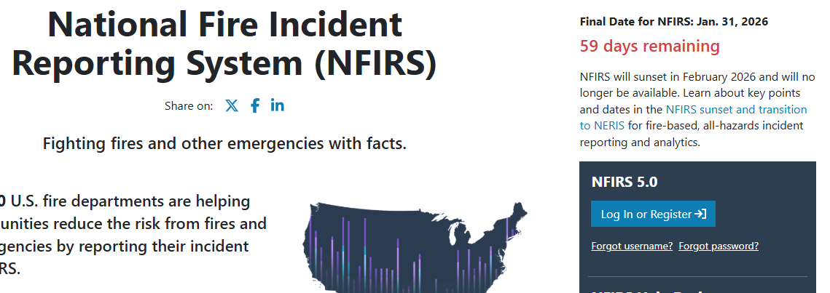
- Once you're in, go to Incident Management and click on Export Incidents as you see below. This will bring you to the “Bulk Export Incidents” page.
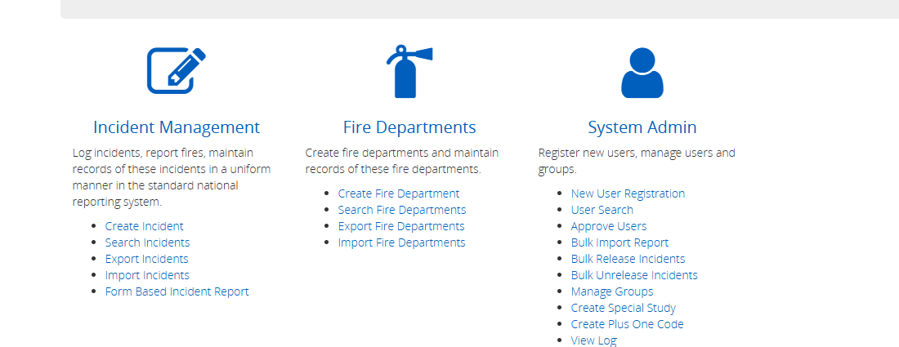
- On the Bulk Export Incidents page, enter your departments name in the “User Group or Fire Department ID” field, select the year you want your incident reports from, and click on “Export All”
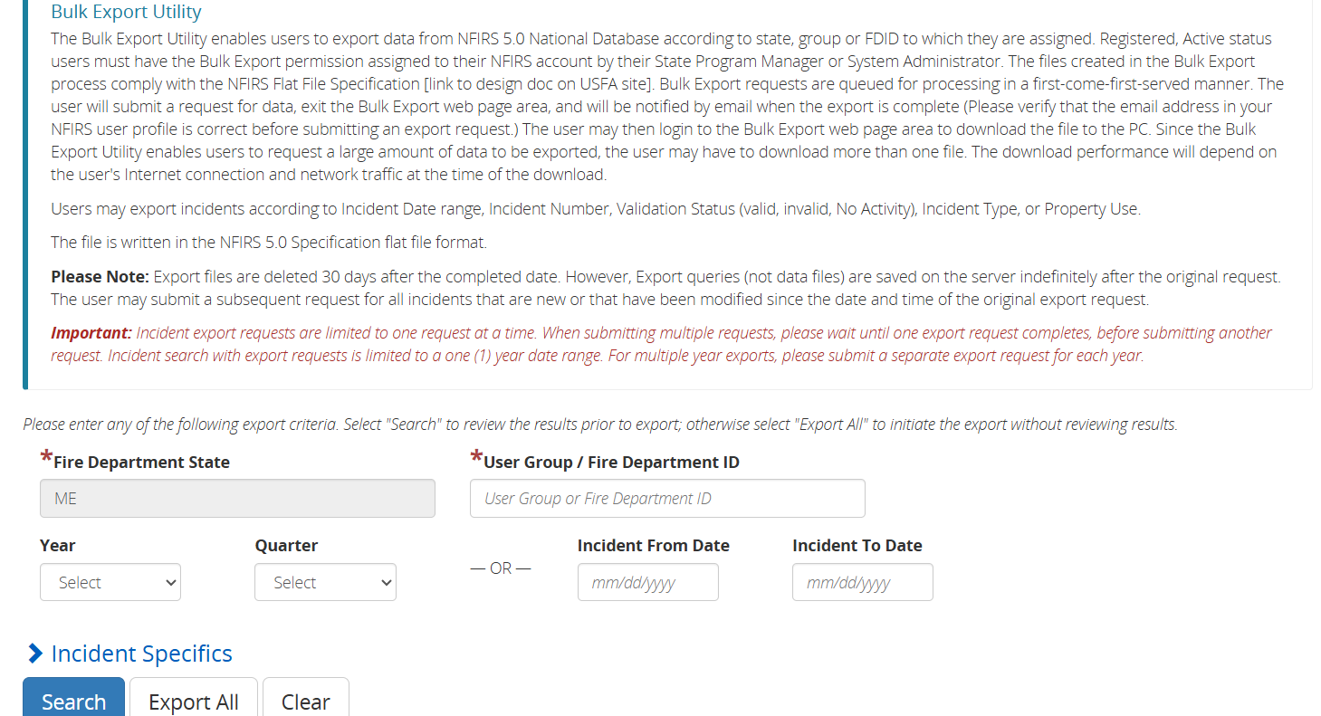

6. You’ll receive a notice in your e-mail that your export is complete. Log back in and go back to the Bulk Export Incidents” page (follow step 4 about). Once your in the “Bulk Incidents” page click on “Recent Incidents” in the tab above.
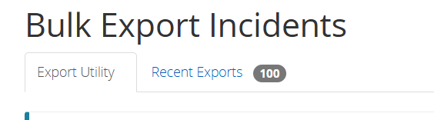
7. When you are on the Recent Exports screen you will see a list of export requests uo made. In the column labled “Export Files” click on your request. Once you’ve opened the file, save it to a selected folder and import it into you’re current RMS system.

If you need any assistance or have questions, contact Richard.e.taylor@maine.gov

